**A model for circadian oscillations in the Drosophila period protein (PER)**

**Project Team:**

Matthew Browe, Eric Chen, Tejas Goculdas, Madan Gopal

**Problem statement:**

Circadian rhythms are set and extremely important metabolic processes that cyclically regulate biological outcomes on a 24-hour cycle. This response to 24-hour light cycles is evolutionarily conserved and observed in all domains of life. The circadian rhythm is a stable oscillatory response under steady state conditions. In this study, we seek to recreate the results published by Goldbeter, 1995 [1].

**Progress and Outcomes:**

1. **Validate and reproduce results presented by Goldbeter, 1995:**

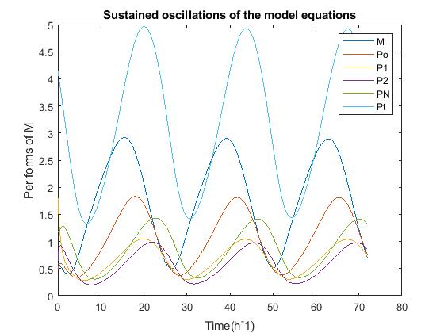

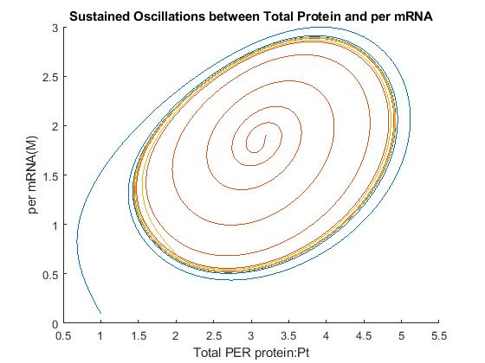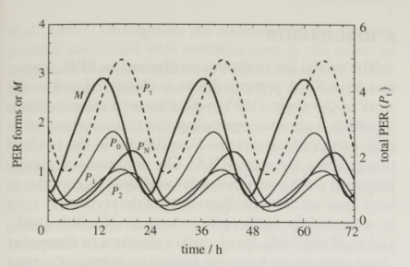Figure 1a and 1b: Oscillatory protein levels from per mRNA (Goldbetter, 1995) and reproduced results

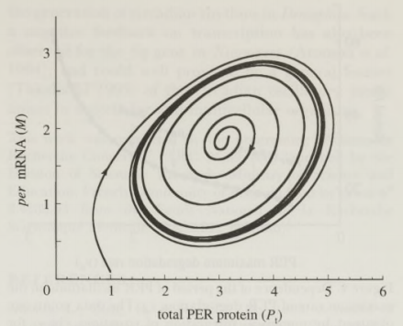

Figure 2a and 2b: All initials conditions favor tendency towards a limit cycle as shown (Goldbetter, 1995) and reproduced results

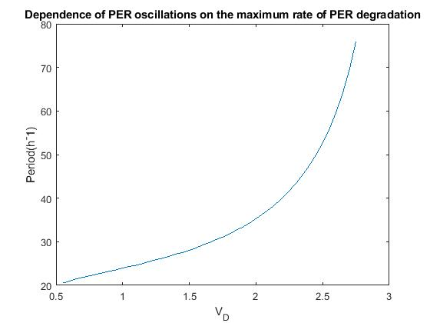

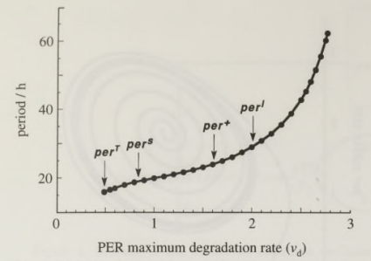

Figure 3a and 3b: Period for per induced oscillation vs. max per protein degradation rate (Goldbetter, 1995) and reproduced results

1. **Stability Analysis Progress:**

We have created a Jacobian matrix from our system of linear differential equations

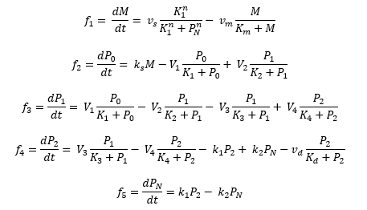

Figure 4: System of five ordinary differential equations that describes PER regulation

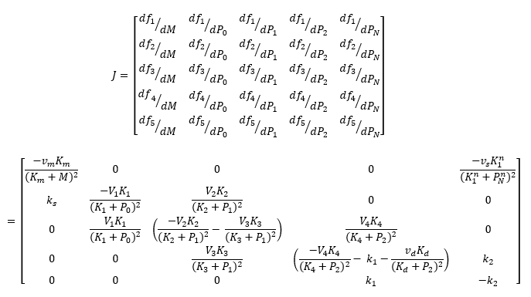

Figure 5: Jacobian matrix of our system of linear ordinary differential equations

1. **Forcing Function – How does Drosophila Respond to Sudden Changes in Daylight Length?**

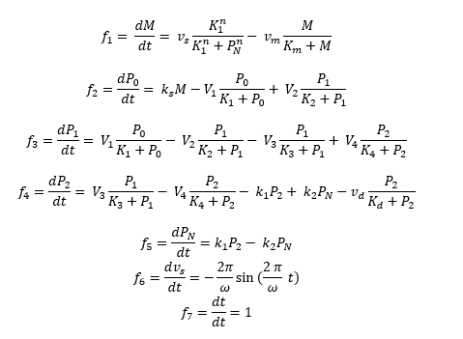

Figure 6: System of seven ordinary differential equations that describes PER regulation under a sinusoidal forcing function

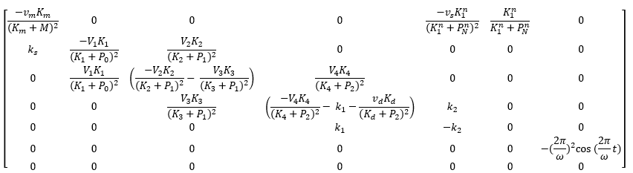

Figure 5: Jacobian matrix with our forcing function

After running this approach by Dr. Lenhoff, we have decided to make some changes to our function setup. We have not yet implemented our changes to the set of ODEs or the Jacobian matrix. This results will be included in our final report.

In addition, we have obtained closed form solutions to the homogenous problem to solve for the steady state values. Dr. Lenhoff advised us that the closed form solutions may not be necessary for this system of linear ODEs, but we will present those results in the appendix of our final report.